**Data Types, Variables, and Operators**

• **Theory:**

**1 . Primitive Data Types in Java (int, float, char, etc.): -**

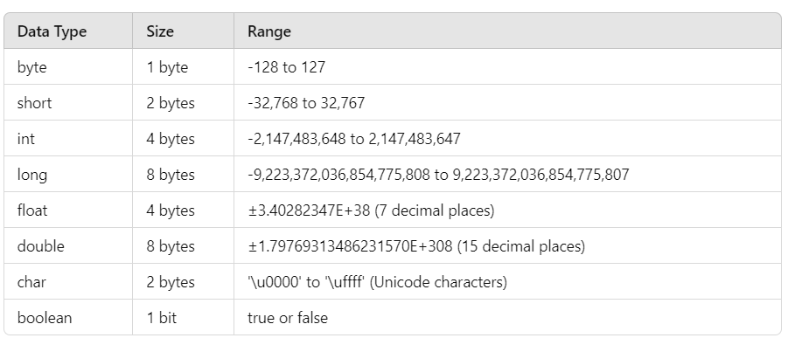

**2.** **Variable Declaration and Initialization :-**

**1. Variable Declaration :-** Variable declaration involves specifying the variable's type and name.

**Syntax :**

DataType variableName;

* **dataType**: This indicates the type of data the variable can hold (e.g., int, float, char).
* **variableName**: This is the name you give to the variable, following Java naming conventions.

**Eg :** int age; // Declares an integer variable named age

double salary; // Declares a double variable named salary

char initial; // Declares a char variable named initial

**2. Variable Initialization :-** Initialization assigns a value to a declared variable. This can happen at the time of declaration or afterward.

**Eg:** int age = 30; // Declares and initializes age to 30

double salary = 50000.0; // Declares and initializes salary

char initial = 'J'; // Declares and initializes initial

**3. Operators: Arithmetic, Relational, Logical, Assignment, Unary, and Bitwise :-**

* 1. Arithmetic Operators : 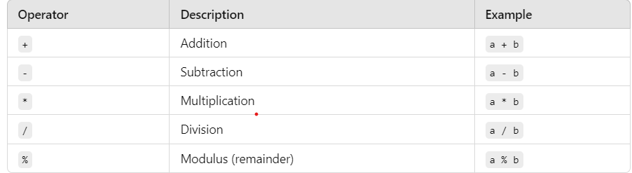
* 2. Relational Operators : 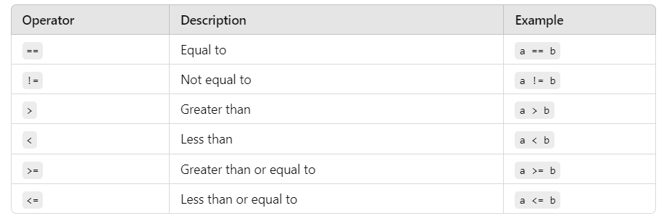
* 3. Logical Operators :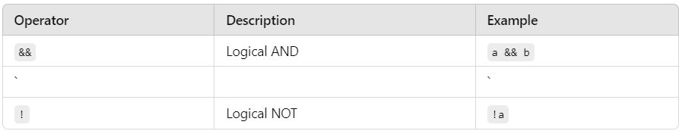
* 4. Assignment Operators :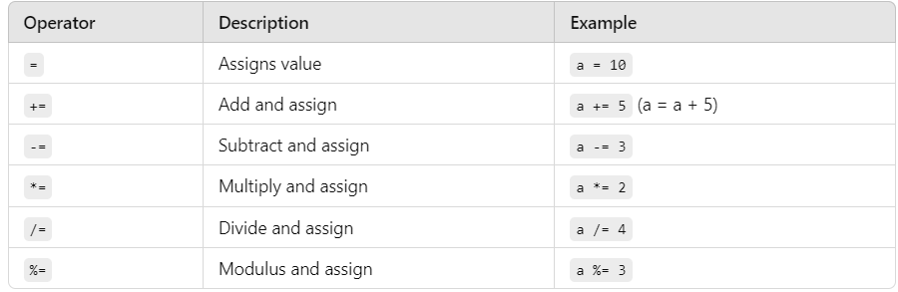
* 5. Unary Operators :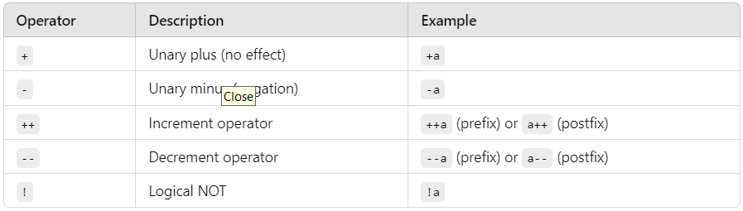
* 6. Bitwise Operators :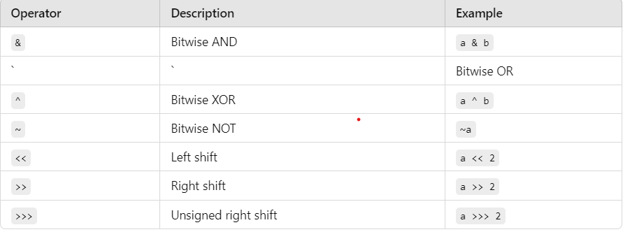

**4. Type Conversion and Type Casting :-**

* **1. Type Conversion :-** Type conversion is the process of converting one data type to another.

**Two Types:**

* Implicit Conversion **:-** This occurs automatically when you assign a value of a smaller data type to a larger data type. The Java compiler handles this conversion without explicit instructions.
* 2.Explicit Conversion :-This type of conversion requires explicit instructions (casting) because you may lose data or precision when converting from a larger data type to a smaller one.
* **2. Type Casting :-** Type casting is the explicit conversion of one data type into another. In Java, you use parentheses to perform casting.

**Two Types:**

* 1.Widening Casting **:-** Widening casting is done automatically and doesn’t require any special syntax. However, for clarity, you can use the syntax if needed.
* **2.Narrowing Casting :-** Narrowing casting must be done explicitly using parentheses.